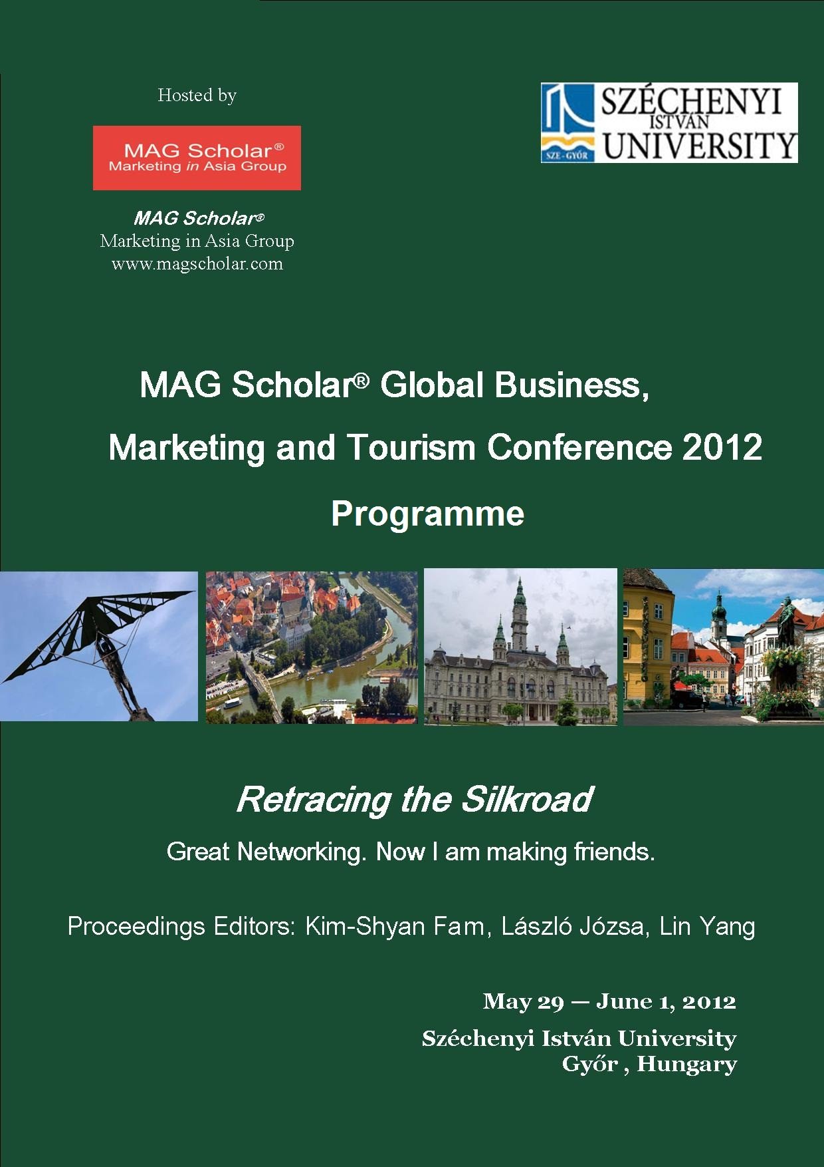

Tuesday: May 29, 2012

Reception 15:00- 18:00 (Cocktail)

Day 1: Wednesday: May 30, 2012

Time | Event at ÚT 231
8:00–8:30 | Registration
8:30–8:45 | Introduction from Judit Koltai
8:45–9:00 | Official welcome from the Széchenyi István University
9:00–9:15 | Welcome Speaker: Kim-Shyan Fam (President of MAG Scholar)
9:15 – 9:25 | Introduction from Pearson Publisher
9:25 – 10:15 | Keynote Speech  László Józsa  Changes in marketing paradigms at the beginning of the 21st century  (East European view of Marketing)

10:15 – 10:45 Morning Tea

Time: 10:45 – 12:15pm
Plenary Session 1
Session Chair: Kim-Shyan Fam
Assistant: Szandra Gombos
Room: ÚT 231

Name | Plenary 1
Richard Fletcher | Are our 'western' derived techniques and approaches suitable for conducting research in developing country markets?
Ernest Cyril De Run | Experience and suggestions on international collaboration in research

Time: 10:45 – 12:15pm
Track 1: Services and Tourism Marketing
Chair: Alfred Ogle
Assistant: Edit Süle
Room: ÚT 229

No | Title of Paper | Authors
1 | A Research on the Role of Municipalities in Tourism Development of Rural Areas: The Case of Turkey | Yüksel Öztürk, Nurettin Ayaz, Rana Allahyari Sani
2 | An Empirical Study in Telecommunicaiton Industry: Value Added Service in Service Quality on Customer Satisfaction and Loyalty Intention | Saowanee Srikanjanaraka
3 | Australia’s business platform into the ASEAN Region | Siva Muthaly
4 | Tis the season to be jolly, Ka-Ching: A study on the commodification of Christmas in the hotel industry | Alfred Ogle

Time: 10:45 – 12:15pm
Track 2: Consumption Marketing
Chair: Kara Chan
Assistant: Szilárd Németh
Room: ÚT 217

No | Title of Paper | Authors
1 | Social Marketing In Practice - Environmental Behaviour Based Segmentation In Hungary | Szabolcs Nagy, István Piskóti, László Molnár, Anita Marien
2 | Are You ‘Fine’ with Writing Instruments? A Review of the Luxury Market | Anouk Robert-Tissot,  Lynn L.K. Lim, Thomas Buergi
3  4 | Attributes of young consumers’ favorite retail shops: A qualitative study  An empirical study on consumer ethnocentrism among young Hungarian customers | Toby C. Y. Yip, Kara Chan,  Evon Poon  László Józsa, Judit Makkos-Káldi, Judit Koltai, Szilárd Németh

12:30pm – Visit to Pannonhalma Monastery

Dinner on your own

End of Day 1

Day 2: Thursday May 31, 2012

Time: 9:00 – 10:30 am
Plenary Session 2
Session Chair: Ernest Cyril De Run
Assistant: Szandra Gombos
Room: ÚT 231

Name | Plenary 2
Kara Chan | The last mile in academic publication: Revising a manuscript
Forrest Yang | The road to JM  Meet the editor of AJBR

Time: 9:00 – 10:30 am
Track 3: Retailing and Marketing Innovations
Chair: Marta Ziółkowska
Assistant: Szilárd Németh
Room: ÚT 229
No | Title of Paper | Authors
1 | Empirical Analysis of Purchase Activity of a Hungarian Food Retailer Chain | Péter Huszka, József Horváth, Judit Makkos-Káldi
2 | Development of Franchising in New Zealand (Franchising opportunities in New Zealand) | Marta Ziółkowska
3 | Staging space: an emerging trend in brand communication in Hong Kong | Francis Hung Yuen Lam, Violet Chan Tze Man, Wendy Shek
4 | Driver of Customer Satisfaction Perspectives from the Food Retail Sector of an Arab Nation | M. Sadiq Sohail, Syed Aziz Anwar, Fuad Hossain Rabbie

Time: 9:00 – 10:30 am
Track 4: Branding
Chair: Andrew Lee Hock Cheong
Assistant: Petra Platz
Room: ÚT 217

No | Title of Paper | Authors
1 | Identification between Individuals and Places of Residence | István Piskóti, Szabolcs Nagy, László Molnár, Anita Marien
2 | Antecedents and consequences of brand attachment among a cross section of Malaysian consumers: a phenomenological study | Andrew Lee Hock Cheong
3 | Determinants of the Confusion between Private Brand and Manufacturer Brand | Pedro Quelhas Brito
4 | TOMA by South Moravian students - local or global | Martin Přibyl
10:30 – 11:00 am Morning Tea

Time: 11:00 – 12:30 pm
Track 5: Consumer Behaviour
Chair: Zoltán Veres
Assistant: Boglárka Eisingerné Balassa
Room: ÚT 231

No | Title of Paper | Authors
1 | "BUYologic” in stepfamilies | Boglárka Eisingerné Balassa, Petra Platz
2 | Lifestyle and Consumption based Segmentation of Budapest Citizens | Zoltán Veres, Erika Hlédik, József Hack-Handa
3 | Cognitive Customer Experience of Women Shopper in Personal Interaction in Thailand’s Department Store | Siripat Chodchuang,  Mahmod Sabri Haron
4 | Commercialization of Social Goods: A Behavioral Analysis | Masroor Ahmad Beg

Time: 11:00 – 12:30 pm
Track 6: Digital Marketing
Chair: Slawomir Smyczek
Assistant: Andrea Sólyom
Room: ÚT 229

No | Title of Paper | Authors
1 | Three Factor Relation Model of Patients with the Medical Units in the Virtual Environment | Slawomir Smyczek,  Justyna Matysiewicz
2 | Key parameters to create a successful deal on Groupon® | Mohammad Hossein Askariazad,  Davood Mirzabagherian, Arash Neishabouri, Seyed Sina Sajjadi
3 | Digital Inequality amongst University Students in the Tshwane Region | Wilfried Ndiaye Kassangoye, Johan De Jager,  Robert Rugimbana

12:30 – 1:30 pm Lunch at Széchenyi Restaurant

Time: 1:30– 3:00 pm
Track 7: Marketing Communications
Chair: Wendy Shek
Assistant: Petra Platz
Room: ÚT 231

No | Title of Paper | Authors
1 | Changing brand communication mode in China | Francis Hung Yuen Lam,Violet Chan Tze Man, Wendy Shek
2 | Social Media: Changing Role of Public Relations’ Tools | Márta Konczos Szombathelyi,  Veronika Keller
3 | Fashion Marketing in Asia – Negotiations between Fashion Marketers and Print Media Practitioners | Tommy H. L. Tse

Time: 1:30– 3:00 pm
Track 8: Marketing in Asia
Chair: Ernest Cyril De Run
Assistant: Judit Makkos-Káldi
Room: ÚT 229

No | Title of Paper | Authors
1 | Can Emic variables be truly culture specific - is Guanxi unique to China? | Richard Fletcher, Tendai Chikweche, John Stanton
2 | A study on the outdoor posters effectiveness in Hong Kong | Maggie S. K. Fung
3 | Malaysian Adolescents View of Controversial Advertising | Ernest Cyril de Run,  Abdul Mukmin bin Alias

Time: 3:30– 5:00 pm
Track 9: Marketing Strategy and Supply Chain Management
Chair: Len Tiu Wright
Assistant: Andrea Sólyom
Room: ÚT 231

No | Title of Paper | Authors
1 | The Exercise of Power Sources in Distribution Channels: A Synthesis Study | Angelina Hanh Nhat Le,  Julian Ming-Sung Cheng
2 | Relational Capital and Export Performance | Naval Bajpai,  Praveen Gupta
3 | The Influence of Brands on Export Pricing | Robert Bradshaw,  Len Tiu Wright, Hulya Oztel , Mark Burridge
4 | Managing Uncertainty in Marketing Channels: A Dynamic Effect of Firm Competence and Institutional Capital | Forrest Yang,  Dongsheng Zhou

Time: 3:30– 5:00 pm
Track 10: Organizational Behaviour
Chair: Raida Abu Bakar
Assistant: Viktória Stifter
Room: ÚT 229

No | Title of Paper | Authors
1 | The Adoption of High Performance Work Practices and its Effect on Employee Engagement Does Individual Personality Matters | Raida Abu Bakar,  Fang Lee Cooke,  Nuttawuth Muenjohn
2 | Vox Populi approach to academic journal rankings: An update | James E. Richard,  Kim-Shyan Fam, Geoff Plimmer, Stephan Gerschewski
3  4 | Do Chinese consumers like advertisements of legal professionals?  Meet the Guest Editor of special Issue of Industrial Marketing Management | Kara Chan, Vivienne Leung, Lennon Tsang  Zhilin Yang, Chenting Su

Dinner at Raba Hotel
6:30 pm to late
End of Conference

LIST OF PARTICIPANTS

NAME | UNIVERSITY | COUNTRY
Richard Fletcher | University of Western Sydney | Australia
Siva Muthaly | RMIT University | Australia
Alfred Ogle | Australian School of Management | Australia
Dongsheng Zhou | China Europe International Business School | China
Martin Pribyl | Private College of Economic Studies Znojmo | Czech Republic
Kara Chan | Hong Kong Baptist University | Hong Kong
Siu Kuen Maggie Fung | Hong Kong Baptist University | Hong Kong
Francis Hung Yuen Lam | Hong Kong Polytechnic University | Hong Kong
Wendy Beth Shek | Hong Kong Polytechnic University | Hong Kong
Leung Lun Lennon Tsang | Hong Kong Baptist University | Hong Kong
Ho Lun Tommy Tse | Hong Kong Baptist University | Hong Kong
Boglárka Eisingerné Balassa | Széchenyi István University | Hungary
Péter Huszka | Széchenyi István University | Hungary
László Józsa | Széchenyi István University | Hungary
Judit Makkos-Káldi | Széchenyi István University | Hungary
Márta Konczosné Szombathelyi | Széchenyi István University | Hungary
Szabolcs Nagy | University of Miskolc | Hungary
István Piskóti | University of Miskolc | Hungary
Zoltán Veres | Budapest Business School | Hungary
Masroor Ahmad Beg | University of Delhi | India
Praveen Gupta | SMT. Vidyawati Group of Institutions | India
Arash Neishabouri | Sharif University of Technology | Iran
Raida Abu Bakar | University of Malaya & RMIT University | Malaysia
Andrew Lee Hock Cheong | Taylor's University | Malaysia
Ernest De Run | University of Malaysia Sarawak | Malaysia
Kim Shyan Fam | Victoria University of Wellington | New Zealand
Forrest Yang | Victoria University of Wellington | New Zealand
Justyna Matysiewicz | University of Economics in Katowice | Poland
Slawomir Smyizek | University of Economics in Katowice | Poland
Marta Ziółkowska | Warsaw School of Economics | Poland
Pedro Quelhas Brito | University of Porto | Portugal
Robert Rugimbana | Tshwane University of Technology | South Africa
Leng Khim Lim | Zurich University of Applied Science | Switzerland
Julian Ming-sung Cheng | National Central University | Taiwan
Angelina Nhat Hanh Le | National Central University | Taiwan
Siripat Chodchuang | Prince of Songkla University | Thailand
Saowanee Srikanjanarak | Thepsatri Rajabhat University | Thailand
Nurettin Ayaz | Gazi University | Turkey
Yüsel Özturk | Gazi University | Turkey
Len Tiu Wright | University of Huddersfield | United Kingdom

